**Title of Your Mini Lab Project**

### Submitted By

|  |  |
| --- | --- |
| **Student Name** | **Student ID** |
| Student-1 Name | Student-1 ID |
| Student-2 Name | Student-2 ID |
| Student-3 Name | Student-3 ID |
| Student-4 Name | Student-4 ID |
| Student-5 Name | Student-5 ID |

**MINI LAB PROJECT REPORT**

This Report Presented in Partial Fulfillment of the course **CSEXXX: Subject Name in the Computer Science and Engineering Department**



### DAFFODIL INTERNATIONAL UNIVERSITY

**Dhaka, Bangladesh**

**November 2, 2024**

**DECLARATION**

We hereby declare that this lab project has been done by us under the supervision of **Name of the course teacher**, **course teacher’s Designation**, Department of Computer Science and Engineering, Daffodil International University. We also declare that neither this project nor any part of this project has been submitted elsewhere as lab projects.

**Submitted To:**

**Course Teacher’s Name**

Designation

Department of Computer Science and Engineering Daffodil International University

**Submitted by**

|  |  |
| --- | --- |
| Student Name Student ID:  Dept. of CSE, DIU | |
| Student Name Student ID:  Dept. of CSE, DIU | Student Name Student ID:  Dept. of CSE, DIU |
| Student Name Student ID:  Dept. of CSE, DIU | Student Name Student ID:  Dept. of CSE, DIU |

## COURSE & PROGRAM OUTCOME

The following course have course outcomes as following:.

Table 1: Course Outcome Statements

|  |  |
| --- | --- |
| **CO’s** | **Statements** |
| CO1 | **Define** and **Relate** classes, objects, members of the class, and relationships among  them needed for solving specific problems |
| CO2 | **Formulate** knowledge of object-oriented programming and Java in problem solving |
| CO3 | **Analyze** Unified Modeling Language (UML) models to **Present** a specific problem |
| CO4 | **Develop** solutions for real-world complex problems **applying** OOP concepts while  evaluating their effectiveness based on industry standards. |

Table 2: Mapping of CO, PO, Blooms, KP and CEP

|  |  |  |  |  |
| --- | --- | --- | --- | --- |
| **CO** | **PO** | **Blooms** | **KP** | **CEP** |
| CO1 | PO1 | C1, C2 | KP3 | EP1,EP3 |
| CO2 | PO2 | C2 | KP3 | EP1,EP3 |
| CO3 | PO3 | C4, A1 | KP3 | EP1,EP2 |
| CO4 | PO3 | C3, C6, A3,  P3 | KP4 | EP1,EP3 |

The mapping justification of this table is provided in section **4.3.1**, **4.3.2** and **4.3.3**.

# Table of Contents

**Declaration** **i**

Course & Program Outcome ii

1. Introduction 1
   1. Introduction 1
   2. Motivation 1
   3. Objectives 1
   4. Feasibility Study 1
   5. Gap Analysis 1
   6. Project Outcome 1
2. Proposed Methodology/Architecture 2
   1. Requirement Analysis & Design Specification 2
      1. Overview 2
      2. Proposed Methodology/ System Design 2
      3. UI Design 2
   2. Overall Project Plan 2
3. Implementation and Results 3
   1. Implementation 3
   2. Performance Analysis 3
   3. Results and Discussion 3
4. Engineering Standards and Mapping 4
   1. Impact on Society, Environment and Sustainability 4
      1. Impact on Life 4
      2. Impact on Society & Environment 4
      3. Ethical Aspects 4
      4. Sustainability Plan 4
   2. Project Management and Team Work 4
   3. Complex Engineering Problem 4
      1. Mapping of Program Outcome 4
      2. Complex Problem Solving 4
      3. Engineering Activities 5

Table of Contents Table of Contents

1. Conclusion 6
   1. Summary 6
   2. Limitation 6
   3. Future Work 6

References 6

**Chapter 1**

# Introduction

Every chapter should start with 1-2 sentences on the outline of the chapter.

### Introduction

This section should present the background and a problem statement that your project aims to solve.

### Motivation

The computational motivation that encourages you to solve the problem should be stated here clearly. In addition, you can mention why solving this problem will benefit you.

### Objectives

Enumerate the objectives in clear and specific terms.

### Feasibility Study

Put a summary of similar research study, case study, methodological contribution of existing projects, web applications, and mobile apps similar to your work [1].

### Gap Analysis

Here summaries the gap where you intend to work.

### Project Outcome

What are or could be the possible outcomes of your work?

**Chapter 2**

# Proposed Methodology/Architecture

Every chapter should start with 1-2 sentences on the outline of the chapter.

### Requirement Analysis & Design Specification

#### Overview

#### Proposed Methodology/ System Design

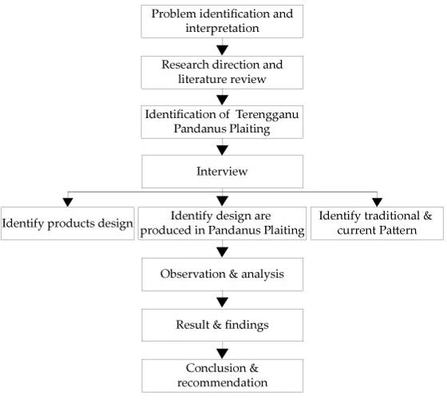

Figure 2.1: This is a sample diagram

#### UI Design

### Overall Project Plan

**Chapter 3**

# Implementation and Results

Every chapter should start with 1-2 sentences on the outline of the chapter.

### Implementation

### Performance Analysis

### Results and Discussion

**Chapter 4**

# Engineering Standards and Mapping

Every chapter should start with 1-2 sentences on the outline of the chapter.

### Impact on Society, Environment and Sustainability

#### Impact on Life

#### Impact on Society & Environment

#### Ethical Aspects

#### Sustainability Plan

### Project Management and Team Work

Provide a cost analysis in terms of budget required and revenue model. In case of budget, you must show an alternate budget and rationales.

### Complex Engineering Problem

#### Mapping of Program Outcome

In this section, provide a mapping of the problem and provided solution with targeted Program Outcomes (PO’s).

Table 4.1: Justification of Program Outcomes

|  |  |
| --- | --- |
| **PO’s** | **Justification** |
| PO1 | Justification of PO1 attainment |
| PO2 | Justification of PO2 attainment |
| PO3 | Justification of PO3 attainment |

#### Complex Problem Solving

In this section, provide a mapping with problem solving categories. For each mapping add subsections to put rationale (Use Table 4.2). For P1, you need to put another mapping with

Chapter 4. Engineering Standards and Mapping 4.3. Complex Engineering Problem Knowledge profile and rational thereof.

Table 4.2: Mapping with complex problem solving.

|  |  |  |  |  |  |  |
| --- | --- | --- | --- | --- | --- | --- |
| EP1  Dept of Knowledge | EP2  Range of Conflicting Require- ments | EP3  Depth of Analysis | EP4  Familiarity of Issues | EP5  Extent of Applicable Codes | EP6  Extent  of Stake- holder Involve- ment | EP7  Inter- dependence |
| *√* | *√* |  |  |  |  |  |

#### Engineering Activities

In this section, provide a mapping with engineering activities. For each mapping add subsections to put rationale (Use Table 4.3).

Table 4.3: Mapping with complex engineering activities.

|  |  |  |  |  |
| --- | --- | --- | --- | --- |
| EA1  Range of re- sources | EA2  Level of Interac- tion | EA3  Innovation | EA4  Consequences for society and envi- ronment | EA5  Familiarity |
| *√* | *√* |  |  |  |

**Chapter 5**

# Conclusion

Every chapter should start with 1-2 sentences on the outline of the chapter.

### Summary

### Limitation

### Future Work

# References

[1] Jon Kleinberg and Eva Tardos. *Algorithm design*. Pearson Education India, 2006.